RESOLUTION NO.__________

RE: CERTIFICATE OF APPROPRIATENESS UNDER THE
PROVISIONS OF THE ACT OF THE PENNSYLVANIA
LEGISLATURE 1961, JUNE 13, P.L. 282 (53
SECTION 8004) AND BETHLEHEM ORDINANCE NO.
3952 AS AMENDED.

WHEREAS, it is proposed to apply lettering and badge emblem on the inside of the storefront glass window and door of the new police substation at 324 South New Street.

NOW, THEREFORE, BE IT RESOLVED by the Council of the City of Bethlehem that a Certificate of Appropriateness is hereby granted for the proposal.

Sponsored by: (s)

(s)

ADOPTED BY COUNCIL THIS DAY OF

(s)
President of Council

ATTEST:

(s)
City Clerk

HISTORIC CONSERVATION COMMISSION

CASE #638 -- It is proposed to apply lettering and badge emblem on the inside of the storefront glass window and door of the new police substation at 324 South New Street.
OWNER/APPLICANT: Bethlehem Parking Authority/Mark DiLuzio

The Commission upon motion by Mr. Evans and seconded by Mr. Hudak adopted the proposal that City Council issue a Certificate of Appropriateness for the proposed work described herein:

- The proposal to install lettering and police badge emblem on the inside surface of the glass storefront of the new police substation was presented by Officer Jon Buskirk of the Bethlehem Police Department.

- The proposed signage is comprised of various lettering and police badge emblem applied to the inside surface of the storefront entrance door and adjacent storefront window at the new Bethlehem and Lehigh Police Joint Substation. Proposed lettering is white Ready to Apply (RTA) vinyl lettering of various sizes and fonts; the Bethlehem Police Department badge emblem at center left of the lettering will be multi-colored.

- The Applicant agreed to integrate an emblem of the Lehigh University shield of similar size to the right of center of the Bethlehem Police Department badge emblem in order to balance the police badge emblem.
- The motion for the proposed work was unanimously approved.

JBL: jbl
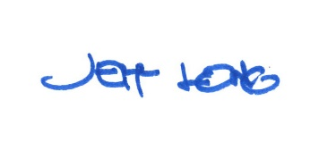

By:

Date of Meeting: February 26, 2018 Title: Historic Officer

